Final Project
IT-204
Karver Stockstill
Professor Homan
April 19, 2026

Introduction
The Birchwood Lane Schools are required to transition from their current paper records to an electronic records system in order to comply with state and federal regulations. Their current record system of student, instructor and course records is outdated, inefficient, and can be time-consuming on issues requiring quick feedback due to extensive search times. A paper system could imply data security issues from use of simple filing cabinets while also the added security of paper files being left in the open. This initiative includes digitizing existing paper files and establishing an efficient framework for managing all future records. Implementing a DBMS will offer Birchwood Lane Schools a modernized and efficient approach to record management
Benefits of the Proposed DBMS for These Roles
A database management system (DBMS) offers numerous advantages to administrators and instructors. It ensures compliance with state and federal regulations, an important objective for Birchwood Lane Schools. With a DBMS, files become easily accessible from one platform, simplifying user experience and enabling quick problem resolution. According to the data requirements, a DBMS provides efficient search and accessibility across major areas such as students, instructors, courses, and enrollments—much faster than traditional paper records. Additionally, it promotes organization and efficiency by eliminating duplicate records, thus ensuring accurate student and instructor information, supporting data integrity, and boosting overall performance.
Explaining the DBMS Capabilities and Benefits to Stakeholders
Although the switch to a DBMS is mandated by state and federal guidelines replacing the old paper filing system, stakeholders should view this transition positively. The change presents an opportunity for everyone to learn how these systems enhance operations and benefit every role. Each user will have centralized access to the information they need, removing the tedious and error-prone process of handling paper files that could be misplaced or lost. The ability for multiple users to retrieve identical information simultaneously reduces time spent gathering data and leads to faster problem-solving.
Business Case and Gap Analysis
Birchwood Lane Schools are required to transition from their current paper records to an electronic records system in order to comply with state and federal regulations. Their current record system of student, instructor and course records is outdated, inefficient, and can be time-consuming on issues requiring quick feedback due to extensive search times. A paper system could imply data security issues from use of simple filing cabinets while also the added security of paper files being left in the open. This initiative includes digitizing existing paper files and establishing an efficient framework for managing all future records. Implementing a DBMS will offer Birchwood Lane Schools a modernized and efficient approach to record management.
A gap analysis is important in identifying and evaluating the differences between the present state, the desired outcomes, and the requirements of the database system (Staff, 2025). The results will illustrate the advantages of adopting a database, including enhanced data security and governance, prevention of record loss inherent in paper systems, reliable backup and recovery, streamlined access for multiple users, and elimination of record duplication for greater accuracy. The DBMS empowers administrators to efficiently manage records by adding new information, updating existing entries, and swiftly retrieving details about students, instructors, or courses. Instructors are granted access to input records and monitor course enrollments, ensuring they remain informed. Students benefit from the ability to track their progress within academic courses. This DBMS will improve communication among administrators, students, and instructors by facilitating coordination and fostering greater satisfaction throughout the Birchwood Lane Schools. The proposed DBMS is designed to be user-friendly and accessible to all stakeholders utilizing the database.
Current State
The Birchwood Lane Schools currently use paper records to keep track of student, instructor, and course information. In order to comply with state and federal regulations an electronic record system will be implemented. Though paper records within Birchwood Lane Schools has been working, the process taken for this type of data recording leads room for error. This types of record system is outdated, inefficient, and produces time-consuming tasks on issues that require quick feedback due to the extensive search times. Error and omission is a big concern with the use of paper records, having important information misplaced by not being filed properly or duplicate information withing records from different departments adding the same record not knowing it is already in the file, this causes confusion and redundancy. The use of a paper record system puts on hold objectives that might involve different departments needing the same file but needing to wait in order to access and get the information that they need. Though data security can be a cause of concern, especially in an event that could lead to total loss of records, and electronic record system does not completely eliminate this concern; with hackers and overall computer security creating a new cause of concern. Though with proper data governance/maintenance and the implementation of a DBMS security procedure the risk can be monitored and lowered.
Future State
The Birchwood Lane Schools needs to implement an electronic record system that will store all student, instructor, and course data. The required data for this database consists of student data; full name, full address, phone, email, birthday, enrollment date, graduation date, courses taken, and courses currently enrolled in. Instructor data: full name, full address, phone, email, birthdate, hire date, courses taught, and courses currently assigned. Lastly, course data; course name, course stare date, course end date, course category, instructor, and students.
In addition to the required data needed, entity relationships within the database need to be established. Birchwood Lane Schools addresses that each student and instructor may have multiple address and be enrolled in multiple courses during each term. Additionally, each instructor may teach multiple courses during the same term. In order to configure all of the necessary elements within the DBMS each entity and corresponding relationship needs to be clearly defined.
Relational Database Model
From the information required along with the additional information needed, I developed a relational database modes that outlines the entities, attributes, and the relationships occurring between them. The model includes four key entities: STUDENT, INSTRUCTOR, COURSE, and ENROLLEDCOURSE, with also indications of Primary Keys, Foreign Keys, multivalued attributes, and composite attributes. A Primary Key ensures that data in a specific column is unique withing that specific column, a Foreign Key is used the determine the relationship between tables through the Primary Key of one table acting as a foreign key in another table (Geeks, 2025). A multivalued attribute stores more than one value at a time of the same type of attribute identified, while a composite attribute is a composition of one or more simple attributes (Varma, 2024).
The student entity will store all data that is relevant to the student, with PhoneNumber established as a multivalued attribute, with composite attributes StuFullname and Address, also including additional attribute of grades. Attribute StudentID was created as a Primary Key (PK) differentiating each student. The INSTRUCTOR entity follows the requirements needed for instructors, PhoneNumber established as a multivalued attribute, with composite attributes InstFullname and Address. Attribute InstructorID was created as a Primary Key (PK) differentiating each instructor. The entity COURSE contains all the data related to courses that are offered establishing CourseID as the Primary Key (PK). The creation of the entity ENROLLEDCOURSE was established as the connection where the relationship between STUDENTS, INSTRUCTORS, and COURSES can be identified. The primary keys explained will become the Foreign Keys (FK) withing the ENROLLEDCOURSE entity.
The relationships involved with the entities are many to many and many to one. A many to many (M:N) relationship is when one table can relate to many in another table, with the optional choices that signify that a relation does not need to occur or with mandatory choices where at least one from a table must relate at least once to the other (Lu, 2026). A many to one relationship will signify that one record in a table can relate to many in another, but one table will require only one specific relation (Lu, 2026).
The relationship between STUDENT and ENROLLEDCOURSE is a many-to-many relationship. Each STUDENT can enroll in many courses but must be enrolled in at least one (mandatory), while ENROLLEDCOURSE can have many students, but must have at least one (mandatory). The relationship between INSTRUCTOR and ENROLLEDCOURSE is also many to many. With each ENROLLEDCOURSE having the option of multiple instructors teaching the same course, but at least one will be teaching it (mandatory), while each instructor can teach multiple courses, but needs to teach at least one (mandatory). The relationship between COURSE and ENROLEEDCOURSE is many to one. With each COURSE being assigned to many ENROLLEDCOURSE with a mandatory of one, and each ENROLLEDCOURSE having a mandatory or one COURSE related to it through CourseID.
Basic relational database visualization
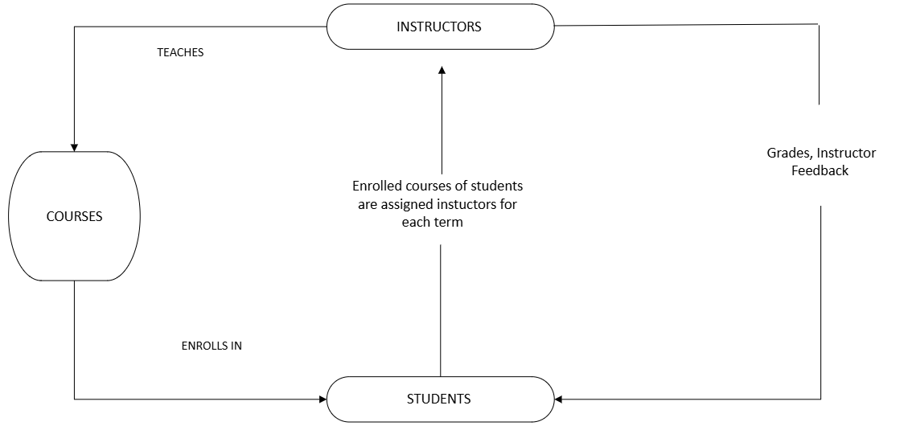

Conceptual data model visualization
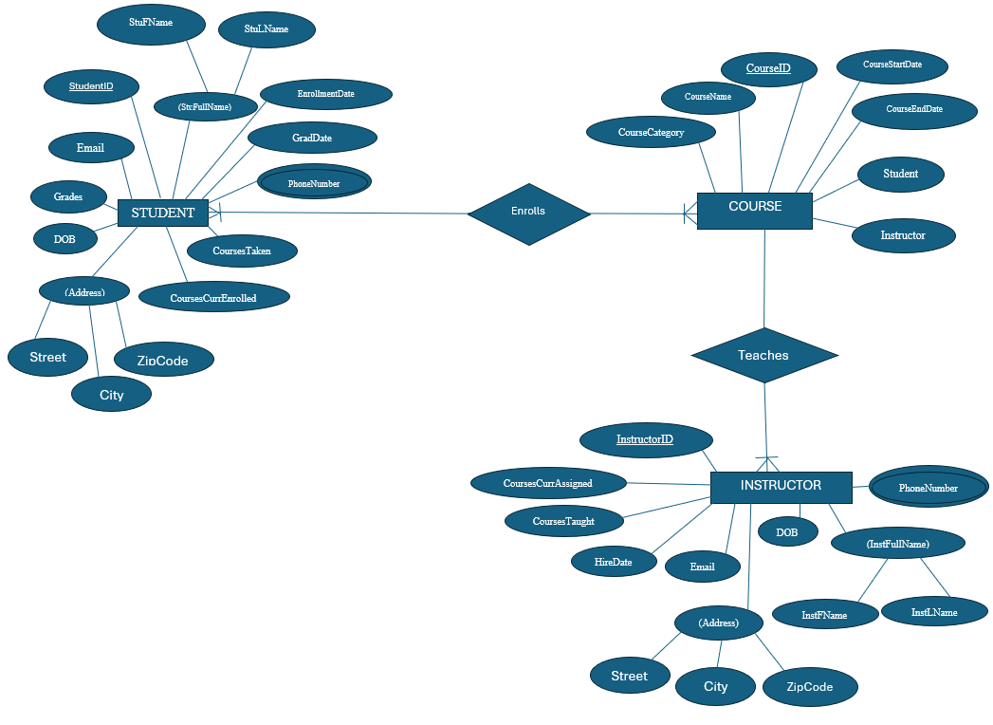

Logical Data Model
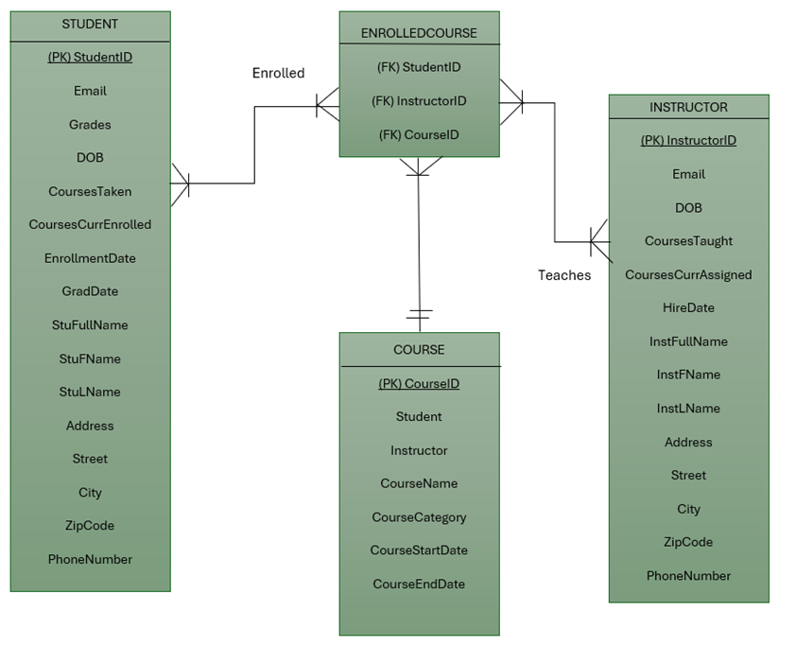
Database Selection
The Birchwood Lane Schools would be benefit from using a MS SQL Server DBMS. An MS SQL Server has a large database capacity of 524 petabytes that allow for the database to grow alongside the Birchwood Lane Schools. Having the ability to have a single table be up to 1,024 columns; key limitations of primary, foreign, and index keys restricted to 32 columns, and statements SELCECT, INSERT, and UPDATE able to handle up to 4,096 columns (Build4, 2025). The cost of this DBMS for the Birchwood Lane would be minimum $989 for standard server to $15,123 for an enterprise edition of this DBMS model (Microsoft, 2026). With Birchwood Lane Schools not being a large enterprise but still have a large amount of data the standard server edition would be my recommendation.
SQL Server Management Studio (SSMS) is a comprehensive, integrated client tool designed for managing SQL Server and Azure SQL Database servers. SSMS lets administrators perform tasks using Object Explorer, which provides graphical access to any server within the SQL Server family. These servers can include instances of the Database Engine, Analysis Services (SSAS), Reporting Services (SSRS), Integration Services (SSIS), Azure SQL Managed Instance, or Azure SQL Database. SSMS offers various tool components, such as Registered Servers, Object Explorer, Solution Explorer, Template Explorer, Object Explorer Details page, and the document window (Build, 2025). To open any of these tools, simply choose the tool name from the View menu. If you want to use the Query Editor, click the New Query button on the toolbar (Build, 2025).
This DBMS supports the operating systems; Windows 2025, 2022, 2019, 2016, 11, and 10 with the recommended standard server edition (Build, 2026). With hardware requirement of at least a 6GB of available hard drive, a monitor with high resolution, functional internet access, minimum memory or 512 mg with a 1gb recommendation, and processing speed of 1.4 GHz with a 2.0 GHZ recommendation (Build, 2026).
This DBMS features SQL server database engine that is the core service for storing, processing, securing data, replication, full-text search, and tools for managing relational data (Build2, 2025). Analysis services include tools for creating and managing online analytical processing and data mining applications (Build2, 2025). Reporting services that includes server and client components necessary for creating, managing, and deploying tabular, matrix and graphical reports (Build2, 2025). Integration services that is a set or graphical tools and programmable objects for moving, copying, and transforming data (Build2, 2025). Machine Learning (ML) services to support distribution, scalable ML solutions support R and Python (Build2, 2025). The ability to query different types of data that come from different data sources withing the SQL server (Build2, 2025).
Clustering is fully supported by this DBMS, monitoring network connections and the health of nodes in the cluster. This is an addition to the health check the DBMS does as a part of the availability group or failover cluster instance feature (Acceldata, 2024). With speed ranges based on factors of index optimization, query execution plan, join optimization and hardware resources (Acceldata, 2024).
Additional key considerations to implement this DBMS would include regular monitoring and optimization of the MS SQL Server DBMS, implementing a robust backup and recovery plan, and ongoing maintenance (Xtivia, 2023). Neglecting these factors may impact system performance. While this DBMS provides various services, it represents a significant investment, especially when accounting for the median annual wage for data administrators, which is $104,620 as of 2024 (U.S., 2026). These costs must be weighed carefully to ensure reliable database maintenance and performance.
Implementation of Relational Database Model
Phase One
- Select the edition to be used
  - Free developer for initial building and testing
  - Recommend standard edition ($989)
- Verify hardware specifications
  - That CPU is x64 processor with a min of 1.4GHz, Ram is min 1GB, and storage has a minimum of 6GB or free space
- Install the proper operating system that has a Windows Server 2025 or 2022 to best align with the standard plan chosen
Phase Two
- Define the tables that will be used and ensure that they do not exceed 1,024 columns
- Assign the data types that will be used throughout the DBMS
- Design indexes to ensure no index key exceeds 32 columns
Phase Three
- Run SQL server setup by installing the core database engine
- Add any shared features needed:
  - Integration services (SSIS) for data movement(Build, 2025).
  - Analysis services (SSAS) if data mining will occur (Build, 2025).
  - Reporting services (SSRS) for report deployment (Build, 2025).
- On administrator workstations install SQL Server Management Studio (SSMS)
Phase Four
- Configure clustering
- Optimize Query Logic that limits SELECT and INSERT statements to 4,096 columns
Phase Five
- Enable Machine Learning Services if R or Python is planned to be run within the database
- Link Azure Synapse if a hybrid cloud environment is chosen
Additional pieces that are necessary in developing a full plan for implementation is to factor in training SQL to staff to ensure that they understand how to work and get results from the DBMS. Establishing a resolute database administrator (DBA) for long term DBMS performance and governance. Understanding how the data will be entered into the system after the initial transfer of paper documentation (manual, CSV or real-time). Maintain regulatory compliance for HIPPA, GDPR and other school district regulations. This regulation compliance is crucial in helping the Birchwood School District prevent legal and financial liability from the data that they gather and store.
Closing Statement
Results of implementing this database will create a monitored data security and governance to the Birchwood Lane Schools with prevention of record loss inherent in paper systems. A reliable backup and recovery system will also be apparent with that added ability of streamlined access for multiple users while provided higher data accuracy by eliminating record duplication. The DBMS empowers administrators to efficiently manage records by adding new information, updating existing entries, and swiftly retrieving details about students, instructors, or courses. Instructors are granted access to input records and monitor course enrollments, ensuring they remain informed. Students benefit from the ability to track their progress within academic courses. This DBMS will improve communication among administrators, students, and instructors by facilitating coordination and fostering greater satisfaction throughout the Birchwood Lane Schools. The proposed DBMS is designed to be user-friendly and accessible to all stakeholders utilizing the database.

Resources
U.S. Bureau of Labor Statistics. (2026). Database Administrators and Architects. https://www.bls.gov/ooh/computer-and-information-technology/database-administrators.htm#:~:text=Database%20administrators%20and%20architects%20typically,the%20average%20for%20all%20occupations.
Acceladata. (2024 December, 8). SQL Performance Tuning Strategies to Optimize Query Execution. https://www.acceldata.io/blog/sql-performance-tuning-strategies-to-optimize-query-execution#:~:text=Index%20optimization:%20Properly%20designed%20indexes,especially%20for%20massive%20data%20queries.
Build4, Microsoft. (2025, August, 21). Maximum capacity specifications for SQL Server. https://learn.microsoft.com/en-us/sql/sql-server/maximum-capacity-specifications-for-sql-server?view=sql-server-ver17#:~:text=If%20the%20table%20contains%20one,Incoming%20=%2010%2C000.
Build, Microsoft. (2025 September, 16). Administer servers with SQL Server Management Studio. https://learn.microsoft.com/en-us/ssms/administer-servers-with-sql-server-management-studio
Xtivia. (2023 March, 28). Microsoft SQL Server: Advantages and Best Practices for Technical Corporate Decision Makers. https://virtual-dba.com/blog/microsoft-sql-server-advantages-and-best-practices/#:~:text=It's%20worth%20noting%20that%20some,efficient%2C%20effective%2C%20and%20reliable.
Build2, Microsoft. (2025 November, 28). Editions and supported features of SQL Server 2022. https://learn.microsoft.com/en-us/sql/sql-server/editions-and-components-of-sql-server-2022?view=sql-server-ver17#:~:text=SQL%20Server%20Database%20Engine%20includes,use%20to%20develop%20report%20applications.
Microsoft. (2026). SQL Server 2022 pricing. https://www.microsoft.com/en-us/sql-server/sql-server-2022-pricing#:~:text=Table_title:%20SQL%20Server%202022%20pricing1%20Table_content:%20header:,pack%20%7C%20Channel%20availability:%20Volume%20Licensing%20%7C
Build, Microsoft. (2026 February, 27). Hardware and software requirements for SQL Server 2022. https://learn.microsoft.com/en-us/sql/sql-server/install/hardware-and-software-requirements-for-installing-sql-server-2022?view=sql-server-ver17
Staff, Coursera. (2025 October, 15). Gap Analysis: Definition, Examples, and How Tos. https://www.coursera.org/articles/gap-analysis
Lu, Tim. (2026 February, 3). Many to Many Relationship: A Guide to Database Design. https://www.datacamp.com/blog/many-to-many-relationship
GeeksForGeeks. (2025 August, 29). Difference between Primary Key and Foreign Key. https://www.geeksforgeeks.org/dbms/difference-between-primary-key-and-foreign-key/
Varma, Srikanth. (2024 April, 12). Types of Attributes in DBMS. https://www.scaler.com/topics/types-of-attributes-in-dbms/

